October 21, 2019
POE Workshop
PLTW Networking Conference
Presenter: Eric Rice

Using the Engineering Design Process to Speed-Up the Solar-Hydrogen Fuel Cell Car Activity
The Engineering Design Process is at the heart of the predictive engineering analysis (PEA). PEA is a development approach for the manufacturing industry that helps with the design of complex products. Teachers will work through activity design enhancements which include using EDP/PEA and students’ knowledge of mechanisms to develop drive trains for the Solar-Hydrogen Fuel Cell Car Activity.
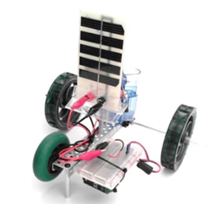

Design Brief

Background:

Problem Statement:

Constraints:

Specifications:

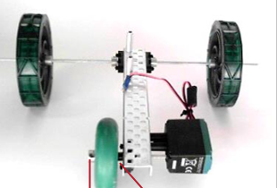
Design and test a gear train, Compound Gear Train, and/or Sprocket & Chain System to enable the vehicle to travel faster.

Sketch the Mechanism

Engineering Calculations (Show how your idea will increase/decrease Torque and Speed)

